Activity-1: This program illustrate the uses of logical operator to calculate Leap Year
Solution:
import java.util.Scanner;
public class Activity41 {
public static void main(String[] args) {
Scanner input = new Scanner(System.in);
System.out.print("Enter a year: ");
int year = input.nextInt();
boolean isLeapYear = (year % 4 == 0 && year % 100 != 0) ||
(year % 400 == 0);
System.out.println(year + " is a leap year? " +
isLeapYear);
}
}
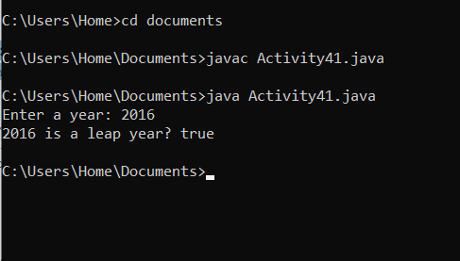
Activity-2: This program prompts the user to enter an integer. If the number is a multiple of 5, the program displays HiFive. If the number is divisible by 2, it displays HiEven
Solution:
import java.util.Scanner;
public class Activity42 {
public static void main(String[] args) {
Scanner input = new Scanner(System.in);
System.out.println("Enter an integer: ");
int number = input.nextInt();
if (number % 5 == 0)
System.out.println("HiFive");
if (number % 2 == 0)
System.out.println("HiEven");
}
}
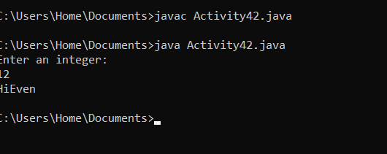

Activity-3: The following program demonstrate if-else concept. It determines an employee’s weekly wages. If the hours worked exceed 40, then wages include overtime payment
Solution:
import java.util.*;
public class Activity43{
static Scanner console = new Scanner(System.in);
public static void main(String [] args){
double wages, rate, hours; //Line 1
System.out.print("Line 2: Enter the working "+ "hours: ");
hours = console.nextDouble();
System.out.println();
System.out.print("Line 5: Enter the pay "+ "rate: ");
rate = console.nextDouble();
System.out.println();
if (hours > 40.0)
wages = 40.0 * rate +1.5 * rate * (hours - 40.0);
else
wages = hours * rate; //Line 11
System.out.printf("Line 12: The wages are $%.2f%n",wages);
System.out.println();
}
}

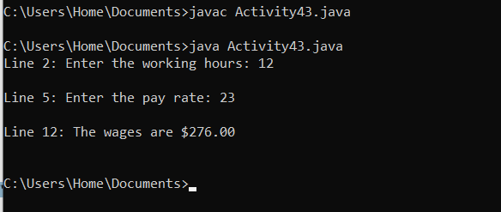

Activity-4: This program illustrate the usage of else-if concept. It calculates the grade based on the score entered by the user
Solution:
import java.util.*;
public class Activity44{
static Scanner console = new Scanner(System.in);
public static void main(String [] args){
int score;
System.out.print(“Enter score: ”);
score = console.nextInt();
if (score >= 90)
System.out.println("The grade is A");
else if (score >= 80)
System.out.println("The grade is B");
else if (score >= 70)
System.out.println("The grade is C");
else if (score >= 60)
System.out.println("The grade is D");
else
System.out.println("The grade is F");
}
}
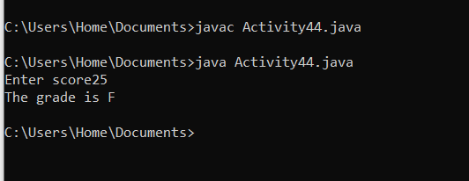
Activity-5: This program demonstrates the working of switch statement.
Solution:
import java.util.Scanner;
public class Activity45{
public static void main(String[] args){
int number;
Scanner input = new Scanner(System.in);
System.out.print("Enter 1, 2, or 3: ");
number = input.nextInt();
switch (number){
case 1:
System.out.println("You entered 1.");
break;
case 2:
System.out.println("You entered 2.");
break;
case 3:
System.out.println("You entered 3.");
break;
default:
System.out.println("That's not 1, 2, or 3!");
}
}
}
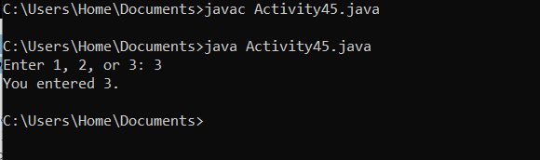

Lab 04
Lab Task 1
Suppose that x, y, and z are int variables and x = 10 , y = 15 , and z = 2 0. Determine whether the following expressions evaluates to true or false . !(x > 1 0) x <= 5 || y < 15 (x != 5 ) && (y != z) x >= z || (x + y >= z) (x <= y – 2) && (y >= z) || (z – 2 != 20)
public class Task01{
public static void main(String[] args){
int x = 10;
int y = 15;
int z = 20;
System.out.println("!(x > 10): " + (!(x > 10)));
System.out.println("x <= 5 || y < 15: " + (x <= 5 || y < 15));
System.out.println("x != 5) && (y > z): " + ((x != 5) && (y > z)));
System.out.println("x >= z || (x+ y > z): " + (x >= z || (x + y > z)));
System.out.println("(x < y - z) && (y > z) || (z-2 != 20): " + ((x < y - z) && (y > z) || (z-2 != 20)));
}
}
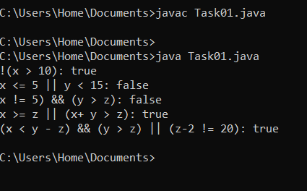
Task 02
Suppose that x, y, z,and w are int variables and x = 3, y = 4, z = 7,and w =1. What is the output of the following statements? System.out.println("x == y: " + (x == y )); System.out.println("x != z: " + (x != z )); System.out.println("y == z – 3: " + (y == z – 3) ); System.out.println("!(z > w): " + ! (z > w)); System.out.println("x + y < z: " + (x + y < z));
solution
public class Output{
public static void main(String[] args){
int x = 3;
int y = 4;
int z = 7;
int w = 1;

System.out.println("x == y: " + (x == y ));
System.out.println("x! z: " + (x != z ));
System.out.println("y == z-3: " + (y == z-3) );
System.out.println("! (z > w): " + ! (z > w ));
System.out.println("x + y < z: " + (x + y < z ));
}
}
Solution:
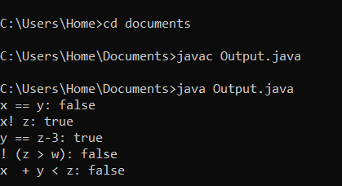

Task 03
Consider the following code segment. Determine the value of b3 boolean b1=true; boolean b2=false; boolean b3=(b1==b2);
Solution;
public class Boolean{
public static void main(String[] args){
boolean b1=true;
boolean b2=false;
boolean b3=(b1==b2);
System.out.print("The value of b3." + b3);
}
}
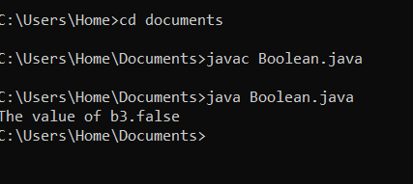
Task 04
- Minimum of two numbers: Given two integers, print the smaller value. b) Minimum of two numbers: Given two integers, print the smaller value. c) Sign function: For the given integer X print 1 if it's positive, -1 if it's negative, or 0 if it's equal to zero. d) Minimum of three numbers: Given three integers, print the smallest value.
- import java.util.Scanner;
- public class Task04{
- public static void main(String[] args){
- Scanner sc = new Scanner(System.in);
- System.out.println("Enter two integers");
- int num1_a = sc.nextInt();
- int num2_a = sc.nextInt();
- int min_a = Math.min(num1_a, num2_a);
- System.out.println("The smaller value for a is" + min_a);
- System.out.println("Enter two integers");
- int num1_b = sc.nextInt();
- int num2_b = sc.nextInt();
- int min_b = Math.min(num1_b, num2_b);
- System.out.println("The smaller value for b is" + min_b);
- System.out.println("Enter an integer for sign fuction");
- int x = sc.nextInt();
- int sign;
- if (x > 0){
- sign = 1;
- } else if (x < 0){
- sign = -1;
- } else {
- sign = 0;
- }
- System.out.println("The sign of" + x + " is : " + sign);
- System.out.println("Enter three integers");
- int num1_d = sc.nextInt();
- int num2_d = sc.nextInt();
- int num3_d = sc.nextInt();
- int min_d = Math.min(num1_d, Math.min(num2_d, num3_d));
- System.out.println("The smallest value for d is :" + min_d);
- sc.close();
- }
- }
- 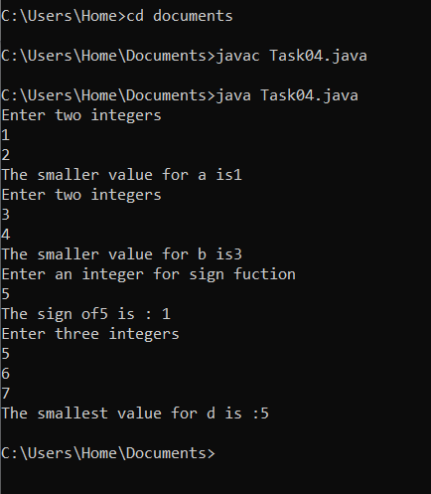

- Lab Task 5 Equal numbers:
Given three integers, determine how many of them are equal to each other. The program must print one of these numbers: 3 (if all are the same), 2 (if two of them are equal to each other and the third is different) or 0 (if all numbers are different).
import java.util.Scanner;
public class Integer{
public static void main(String[] args){
Scanner sc = new Scanner(System.in);
int a;
int b;
int c;
System.out.println("Enter the value of a");
a = sc.nextInt();
System.out.println("Enter the value of b");
b = sc.nextInt();
System.out.println("Enter the value of c");
c = sc.nextInt();
int equalCount;
if(a == b && b == c){
System.out.println("3");
}
else if(a == b || a == c || b == c){
System.out.println("2");
} else {
System.out.println("0");
sc.close();
}
}
}
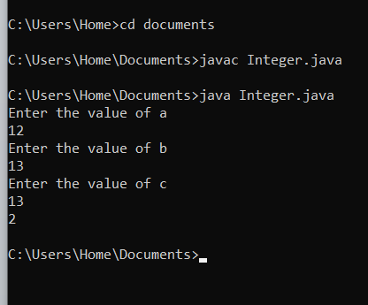

Lab Task 6
Write a program that prompts the user to enter a number within the range of 1 through 10. The program should display the Roman numeral version of that number. If the number is outside the range of 1 through 10, the program should display an error message. The following table shows the Roman numerals for the numbers 1 through 10
import java.util.Scanner;
public class Task06{
public static void main(String[] args){
Scanner sc = new Scanner(System.in);
System.out.print("Enter a number within the range of 1 to 10:");
int num = sc.nextInt();

switch (num){
case 1:
System.out.println("I");
break;
case 2:
System.out.println("II");
break;
case 3:
System.out.println("III");
break;
case 4:
System.out.println("IV");
break;
case 5:
System.out.println("V");
break;
case 6:
System.out.println("VI");
break;
case 7:
System.out.println("VII");
break;
case 8:
System.out.println("VIII");
break;
case 9:
System.out.println("IX");
break;
case 10:
System.out.println("X");
break;

default:
System.out.println("ERROR");
}
}
}
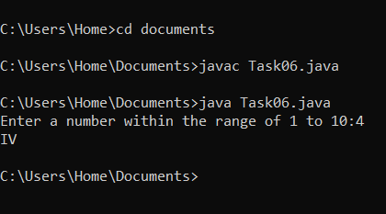
Lab Task 7
The area of a rectangle is the rectangle’s length times its width. Write a program that asks for the length and width of two rectangles. The program should tell the user which rectangle has the greater area, or if the areas are the same.
import java.util.Scanner;
public class Rectangle{
public static void main(String[] args){
Scanner sc = new Scanner(System.in);
int length1;
System.out.println("Enter the length1of rectangle1");
length1 = sc.nextInt();
int width1;
System.out.println("Enter the width1 of rectangle1");
width1 = sc.nextInt();
int area1 = length1 * width1;
int length2;
System.out.println("Enter the length2 of rectangle2");
length2 = sc.nextInt();
int width2;
System.out.println("Enter the width2 of rectangle2");
width2 = sc.nextInt();
int area2 = length2 * width2;
if(area1 > area2){
System.out.println("recatangle1 is greater than rectangle2");
} else {
System.out.println("rectangle2 is grater than rectangle1");
sc.close();
}
}
}
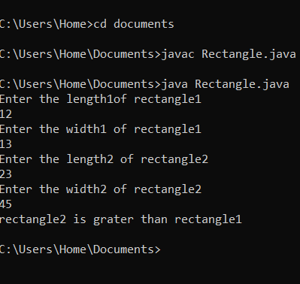
Lab Task 8
The date June 10, 1960, is special because when it is written in the following format, the month times the day equals the year: 6/10/60 Design a program that asks the user to enter a month (in numeric form), a day, and a two-digit year. The program should then determine whether the month times the day equals the year. If so, it should display a message saying the date is magic. Otherwise, it should display a message saying the date is not magic.
import java.util.Scanner;
public class Task08{
public static void main(String[] args){
Scanner sc = new Scanner(System.in);
System.out.print("Enter month in numeric form:");
int month = sc.nextInt();
System.out.print("Enter day in numeric form:");
int day = sc.nextInt();
System.out.print("Enter two-digit year:");
int year = sc.nextInt();

if(month * day == year)
System.out.println("The date is magic:");
else
System.out.println("Date is not magic:");
}
}
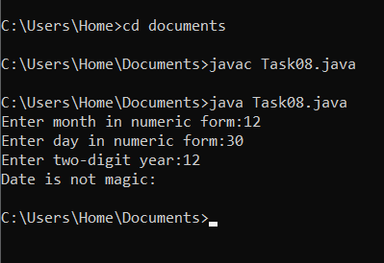
Lab Task 9
Create a change-counting game that gets the user to enter the number of coins required to make exactly one dollar. The program should prompt the user to enter the number of pennies, nickels, dimes, and quarters. If the total value of the coins entered is equal to one dollar, the program should congratulate the user for winning the game. Otherwise, the program should display a message indicating whether the amount entered was more than or less than one dollar. Lab Task 10 Serendipity Booksellers has a book club that awards points to its customers based on the number of books.

